Dragon-eye Setup Notes

The Dragon-eye is an electronic real-time F3F judging system using the Jetson Nano. It is based on the technology of computer vision, capturing a video stream from the camera, then detecting moving objects and tracking them. Once one of the tracked targets crosses the central vertical line a signal is triggered.

1.Architecture
dragon-eye base x 2
Outdoor wifi AP x 1
Android phone x 1

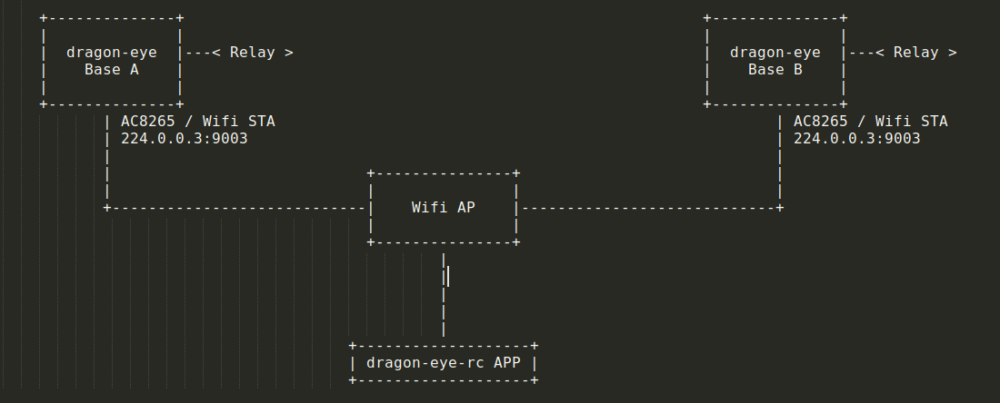
2. Setup wifi access point (AP)
Set up the AP midway between base A and B, keeping the wifi AP as high as possible will improve network reception. Placing the bases to avoid obstructions between the base and the AP will maximise signal strength. Use of the 802.11ac WiFi protocol is preferred if supported by your AP.

3.On slope
The Dragon-eye base should be setup at least 1.5m above ground. Make sure Dragon-eye base is stable, tripod is properly fixed to the ground and the base unit is levelled accurately. Position the base unit to avoid having unnecessary moving objects in the cameras field of view. The constant movement of grass or trees in the field of view will reduce performance. Use 160 degree FoV camera if glider pass by closely.

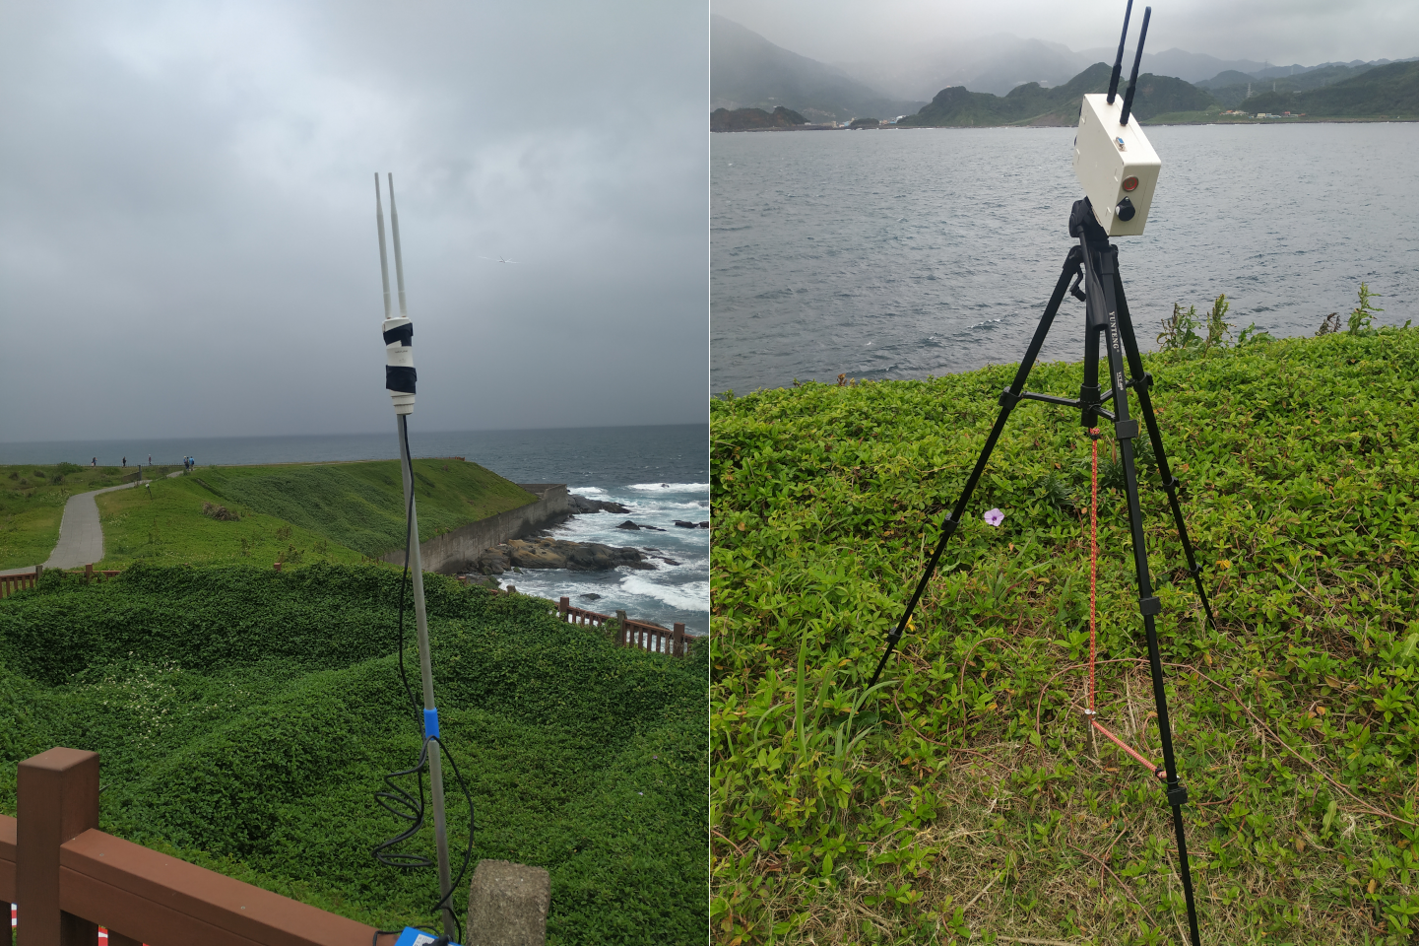

4.Setup dragon-eye base
Setup dragon-eye base from Android APP – dragon-eye-rc. First disconnect the Android phones 4G/5G data network to force the phone to use the Wifi network. Connect Android phone to your Wifi AP and then run APP dragon-eye-rc. Once the APP receives the multicast signal from base units they will appear on the screen.

5.APP dragon-eye-rc
Once the phone APP receives the base signals the initial base status will be “Stopped”, pressing the ‘Start’ button on the bottom left of screen will start detection on all bases. Press the stop button on bottom right of screen of screen to stop detection of all bases.

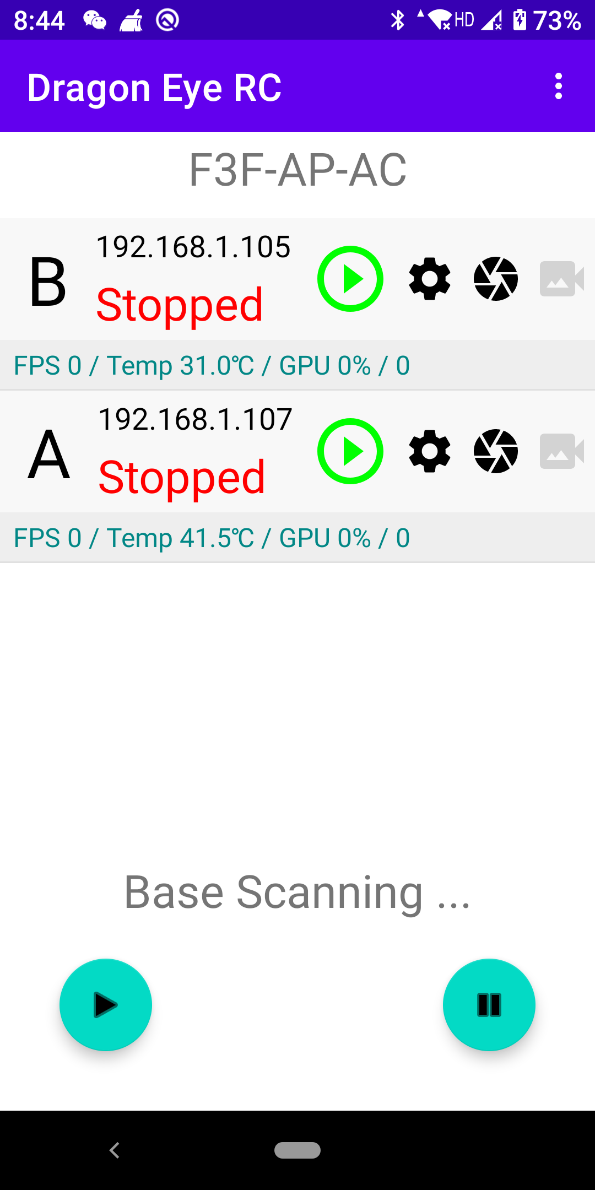

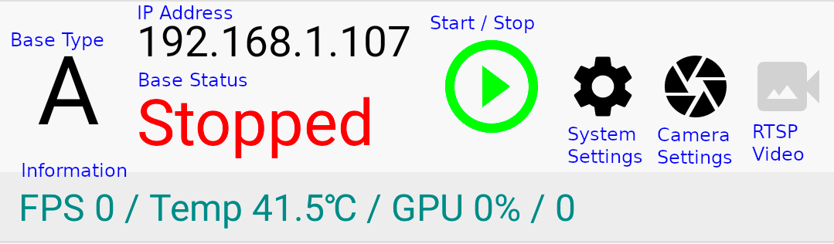

6. System Settings
After changing any settings press save button on the bottom left of the screen. For F3F timing configure one base unit as ‘ Base A ‘ and the second unit as ‘ Base B ‘.

The ‘MOG2 threshold’ setting is the adjustment of background subtraction, the lower the value the more sensitive the camera, but the more noise in the image. The suggested threshold value is between 8 to 32.

‘New Target Restriction’ is a rectangle region (360 x 180pixals) in the bottom central area of camera view in which new targets will not be detected. It is helpful to prevent false triggers when there‘s grass in bottom of camera view.

Fake Target Detection records all new targets in the previous 3 seconds, if there are targets that overlap too many times these targets will be treated as a fake target and will not trigger the system.

Bug trigger is to prevent false triggers caused by bugs flying through the field of view. Bugs are usually small and fast, so targets that are small in size and at high speed will not cause a trigger when they cross the central line.

Video output, for now, works in screen & rtsp video mode. Watch rtsp video on the phone screen after selecting ‘Start’, then touch the camera icon on the APP. If a screen is connected to the Nano’s HDMI output, live camera video will be available after selecting ‘screen’ from the video output menu ( remember to save the change! ) and selecting the camera as above.

Save file. Dragon-eye can save real-time video to the SD card. The maximum number of video files is 400, each video is about 90 seconds. Access to the video file is available through Windows network sharing (Samba).

Show Result, Show detection, trigger and various information on video output is selectable for display on the video output.

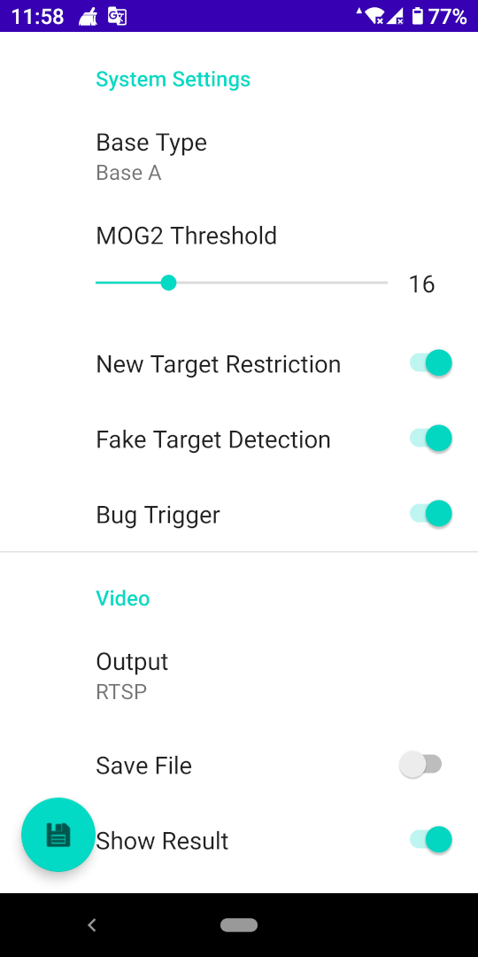
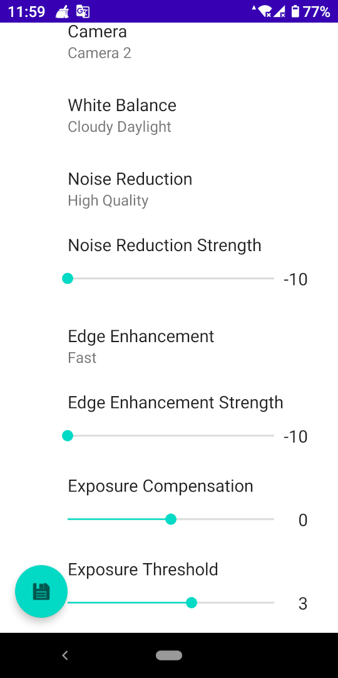

Relay debouence is to prevent multi trigger of detection in short time.

Horizon ratio of screen. There’s an horizon yellow line on RTSP video screen when show result enabled. Keep any terrain background under this line. This will reduce false trigger by terrain.

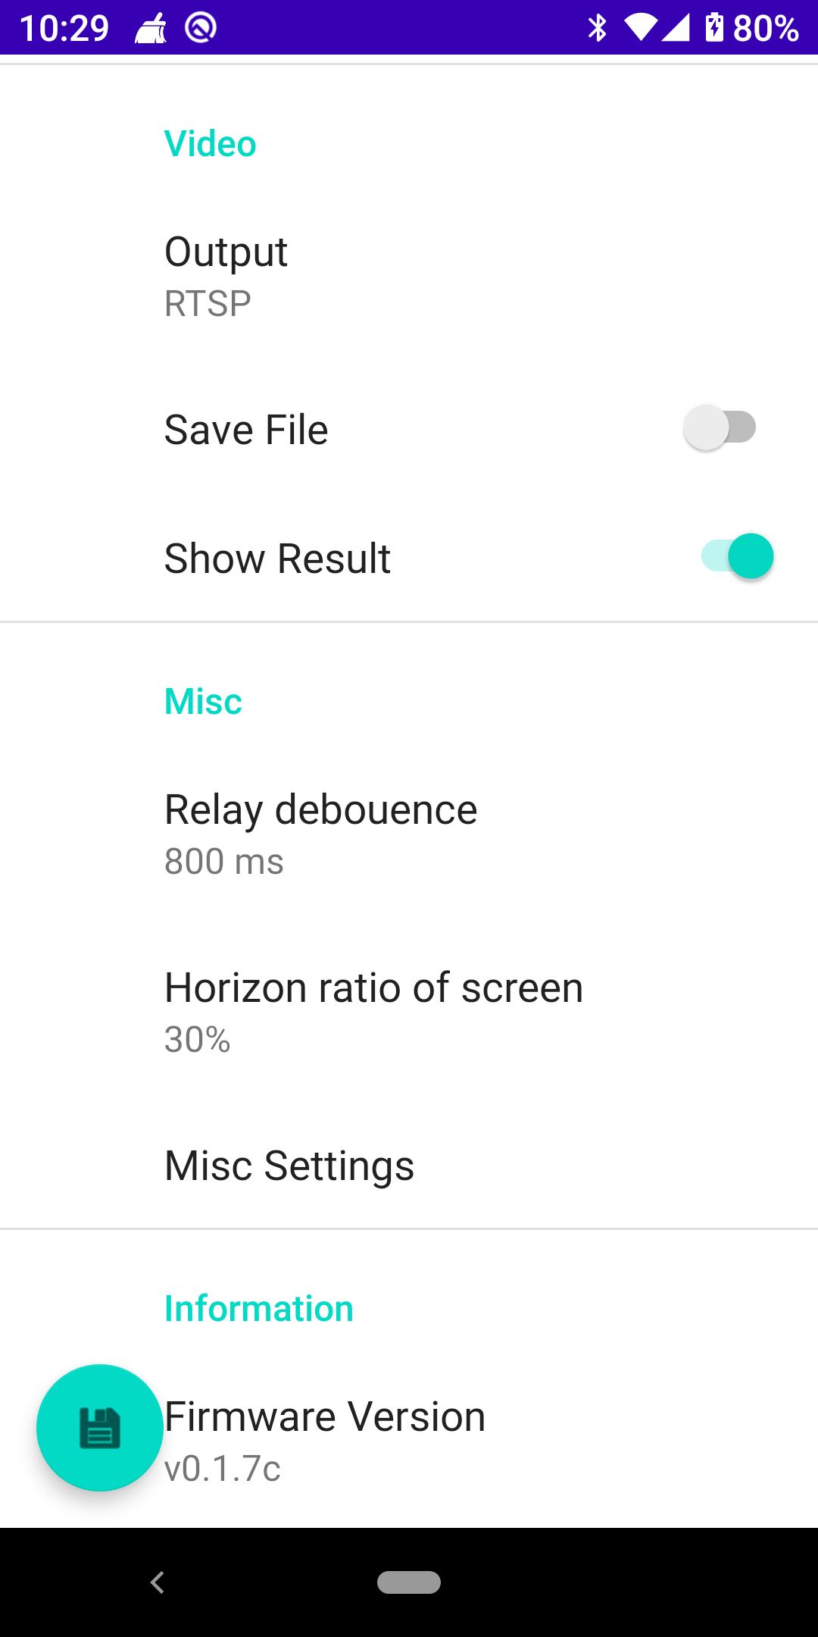

7.Camera Settings
Two cameras are available, each with a different field of view. The conditions and base placement on individual slopes will determine which camera is appropriate for the local slope.
Choice of white balance is selectable depending on weather conditions, auto mode is also effective under most conditions.
It is recommended not to adjust Noise Reduction Strength, Edge enhancement or Exposure Compensation unless you are familiar with these settings.

Exposure Threshold is the most important parameter to achieve good quality video output. Under normal conditions a value of 3 is effective, in very bright conditions producing over exposure lower the setting to 2, or if light is fading try 4.

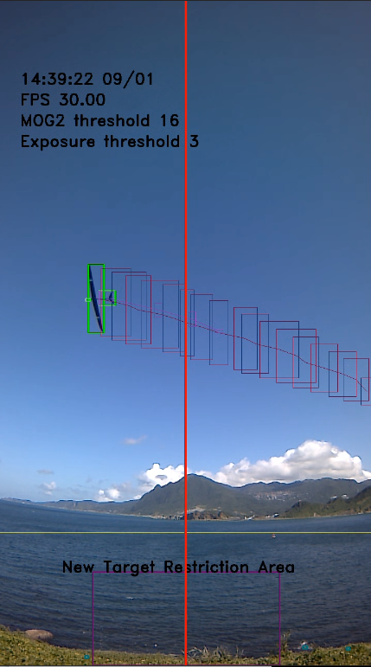

8.F3F Timer
Press top right of the screen and pull down the F3F Timer menu. Please disable power save, and screen saver on the Android phone to keep timer running. An external power supply to the phone is recommended to extend working time. Bluetooth audio output is also selectable from the phone to enable use of bluetooth headphones if phone audio is difficult to hear on a windy day.
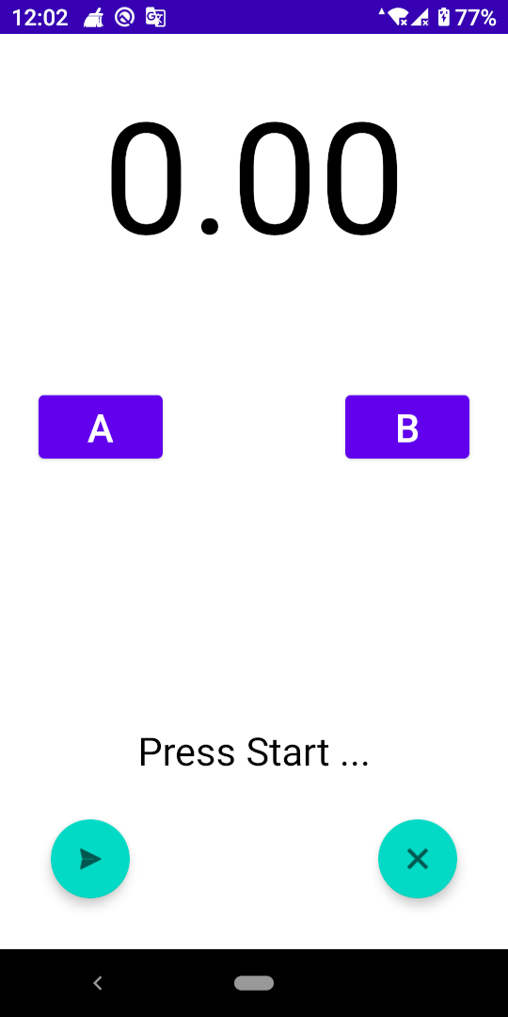

9.Power management
Disable save files / output result / video output to increase battery life if not required.

10.Firmware Upgrade
Upgrade firmware dragon-eye base OTA (on the air) from APP. The firmware is embedded in APP. Go to [System Settings] → [Information] → [Firmware Version]

11.Settings example

Summer daylight

White balance : Auto
Exposure threshold : 2
MOG2 threshold : 16
New Target Restriction : ON / OFF
Fake Target Detection : ON
Bug Trigger : ON

Cloudy daylight

White balance : Auto
Exposure threshold : 3
MOG2 threshold : 12
New Target Restriction : ON / OFF
Fake Target Detection : ON
Bug Trigger : ON

Before sunset

White balance : Auto
Exposure threshold : 4
MOG2 threshold : 12
New Target Restriction : ON / OFF
Fake Target Detection : ON
Bug Trigger : ON

